Notes on “Heart of Darkness”
Vocabulary
Somnambulist-sleep walker
Yawl-type of boat
Concertina-boat reference
Estuary-mouth of river
Trireme-boat with 3 sets of oars
Ominous-threatening or scary
Gauls-ancient French
Celts-ancient British
Nautical-sea
Benign-harmless
Savage-ruthless, uncivilized, greedy, evil
Yarns-stories
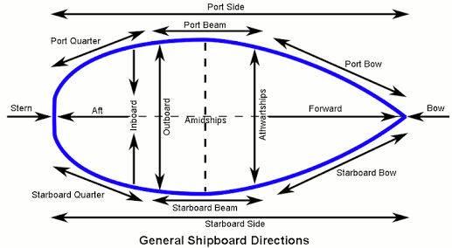
Fore-front of boat where bow is
Aft-back of boat, called also the stern
Thames-temz
Weather-gloomy
Characters
Charlie Marlow
Narrator
Accountant
Director (pilot)
Lawyer
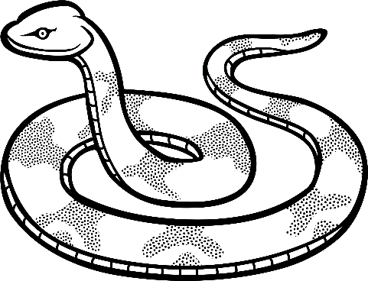
Snake=metaphor for the idea of steamboating up the river
Ave Imperator, Morituri te salutant
Hail Emperor, for those who are about to die, we salute you
Theme
…in the hearts of wild men…everyone has the ability to be savage
Denotation vs. Connotation

