Name |  | Class

Vocabulary for Unit 2:
People and the Environment — LIST 1
Activity 1: In-Context Predictions  Directions: Use context clues to determine the meaning of each of your new vocabulary words. Your teacher will review the correct definitions with you after. The example below shows you how to do this. | 

- Begin by looking at the photo.  Ask yourself, What do I see?  I see birds flying in the air.  They are not being controlled or told where to go.  - Next, look at the caption.  Ask yourself, what word could I use in place of the underlined vocabulary word?  Here I might substitute “all” or “complete” for absolute.  - Then, look at the example sentence.  Ask yourself, do my substitutions from the caption — “all” and “complete” — make sense in this sentence?  Yes, “complete” works in the example sentence as well.  - Finally, write or type a prediction in the last box. |  | Example: Absolute [ab-suh-loot]
 |  | My mother’s no was absolute. Once she said it, there was no chance of changing her mind.

Birds have absolute freedom to go wherever they like.
What’s your prediction?
My Answer: complete
 |  | Correct Definition:

1. Accumulate [uh-kyoo-myuh-leyt] |  | - Contaminate [kuhn-tam-uh-neyt]
I started with one pair of sneakers, but over the years,  I’ve accumulated more than 40 pairs! |  | When the sewer leaked,  it contaminated our drinking water.
  Six inches of snow accumulated overnight. |  | 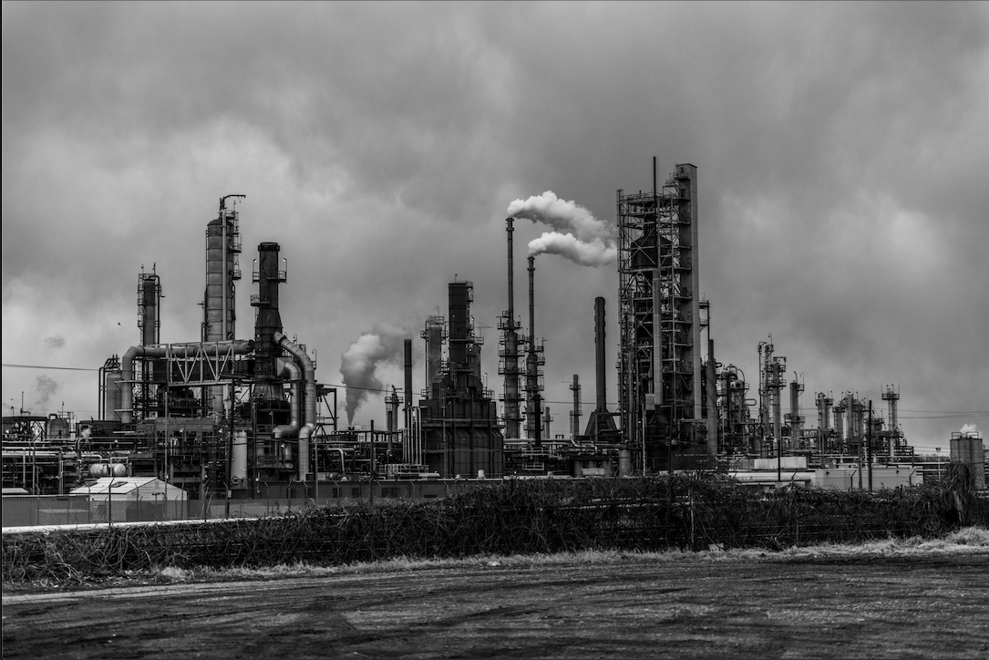  The smoke from the factory contaminated the air.
What’s your prediction?  My Answer: |  | What’s your prediction?  My Answer:
Correct Definition: |  | Correct Definition:

3. Dispose [dih-spohz] |  | 4. Emissions [ih-mish-uhnz]
Please dispose of your dirty tissues in the trash can. |  | The emissions from the factory can make it hard to breathe.
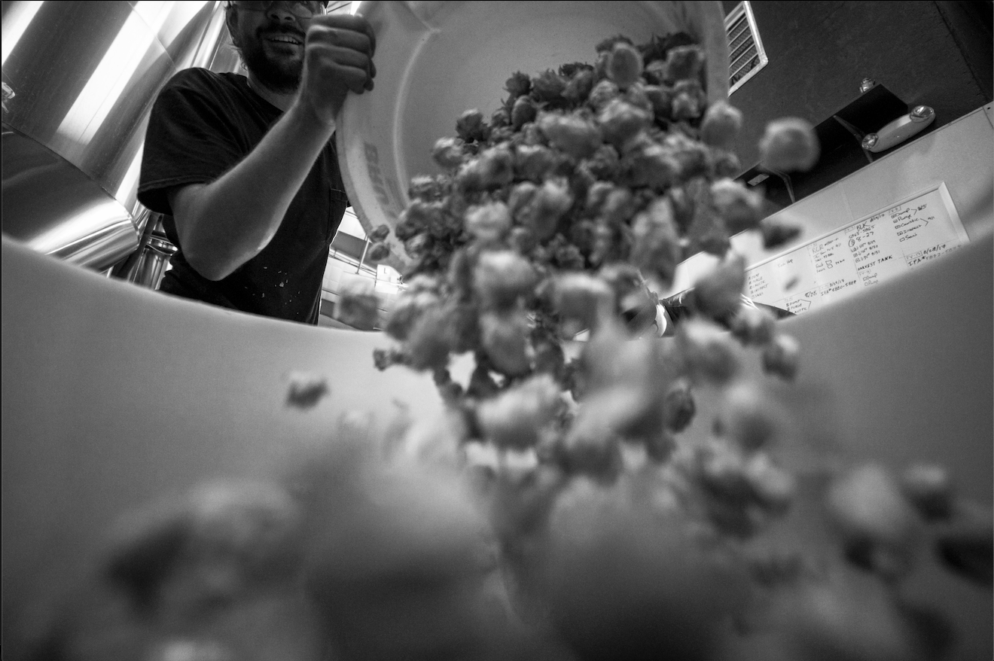  I had to dispose of the vegetables that had gone bad. |  | 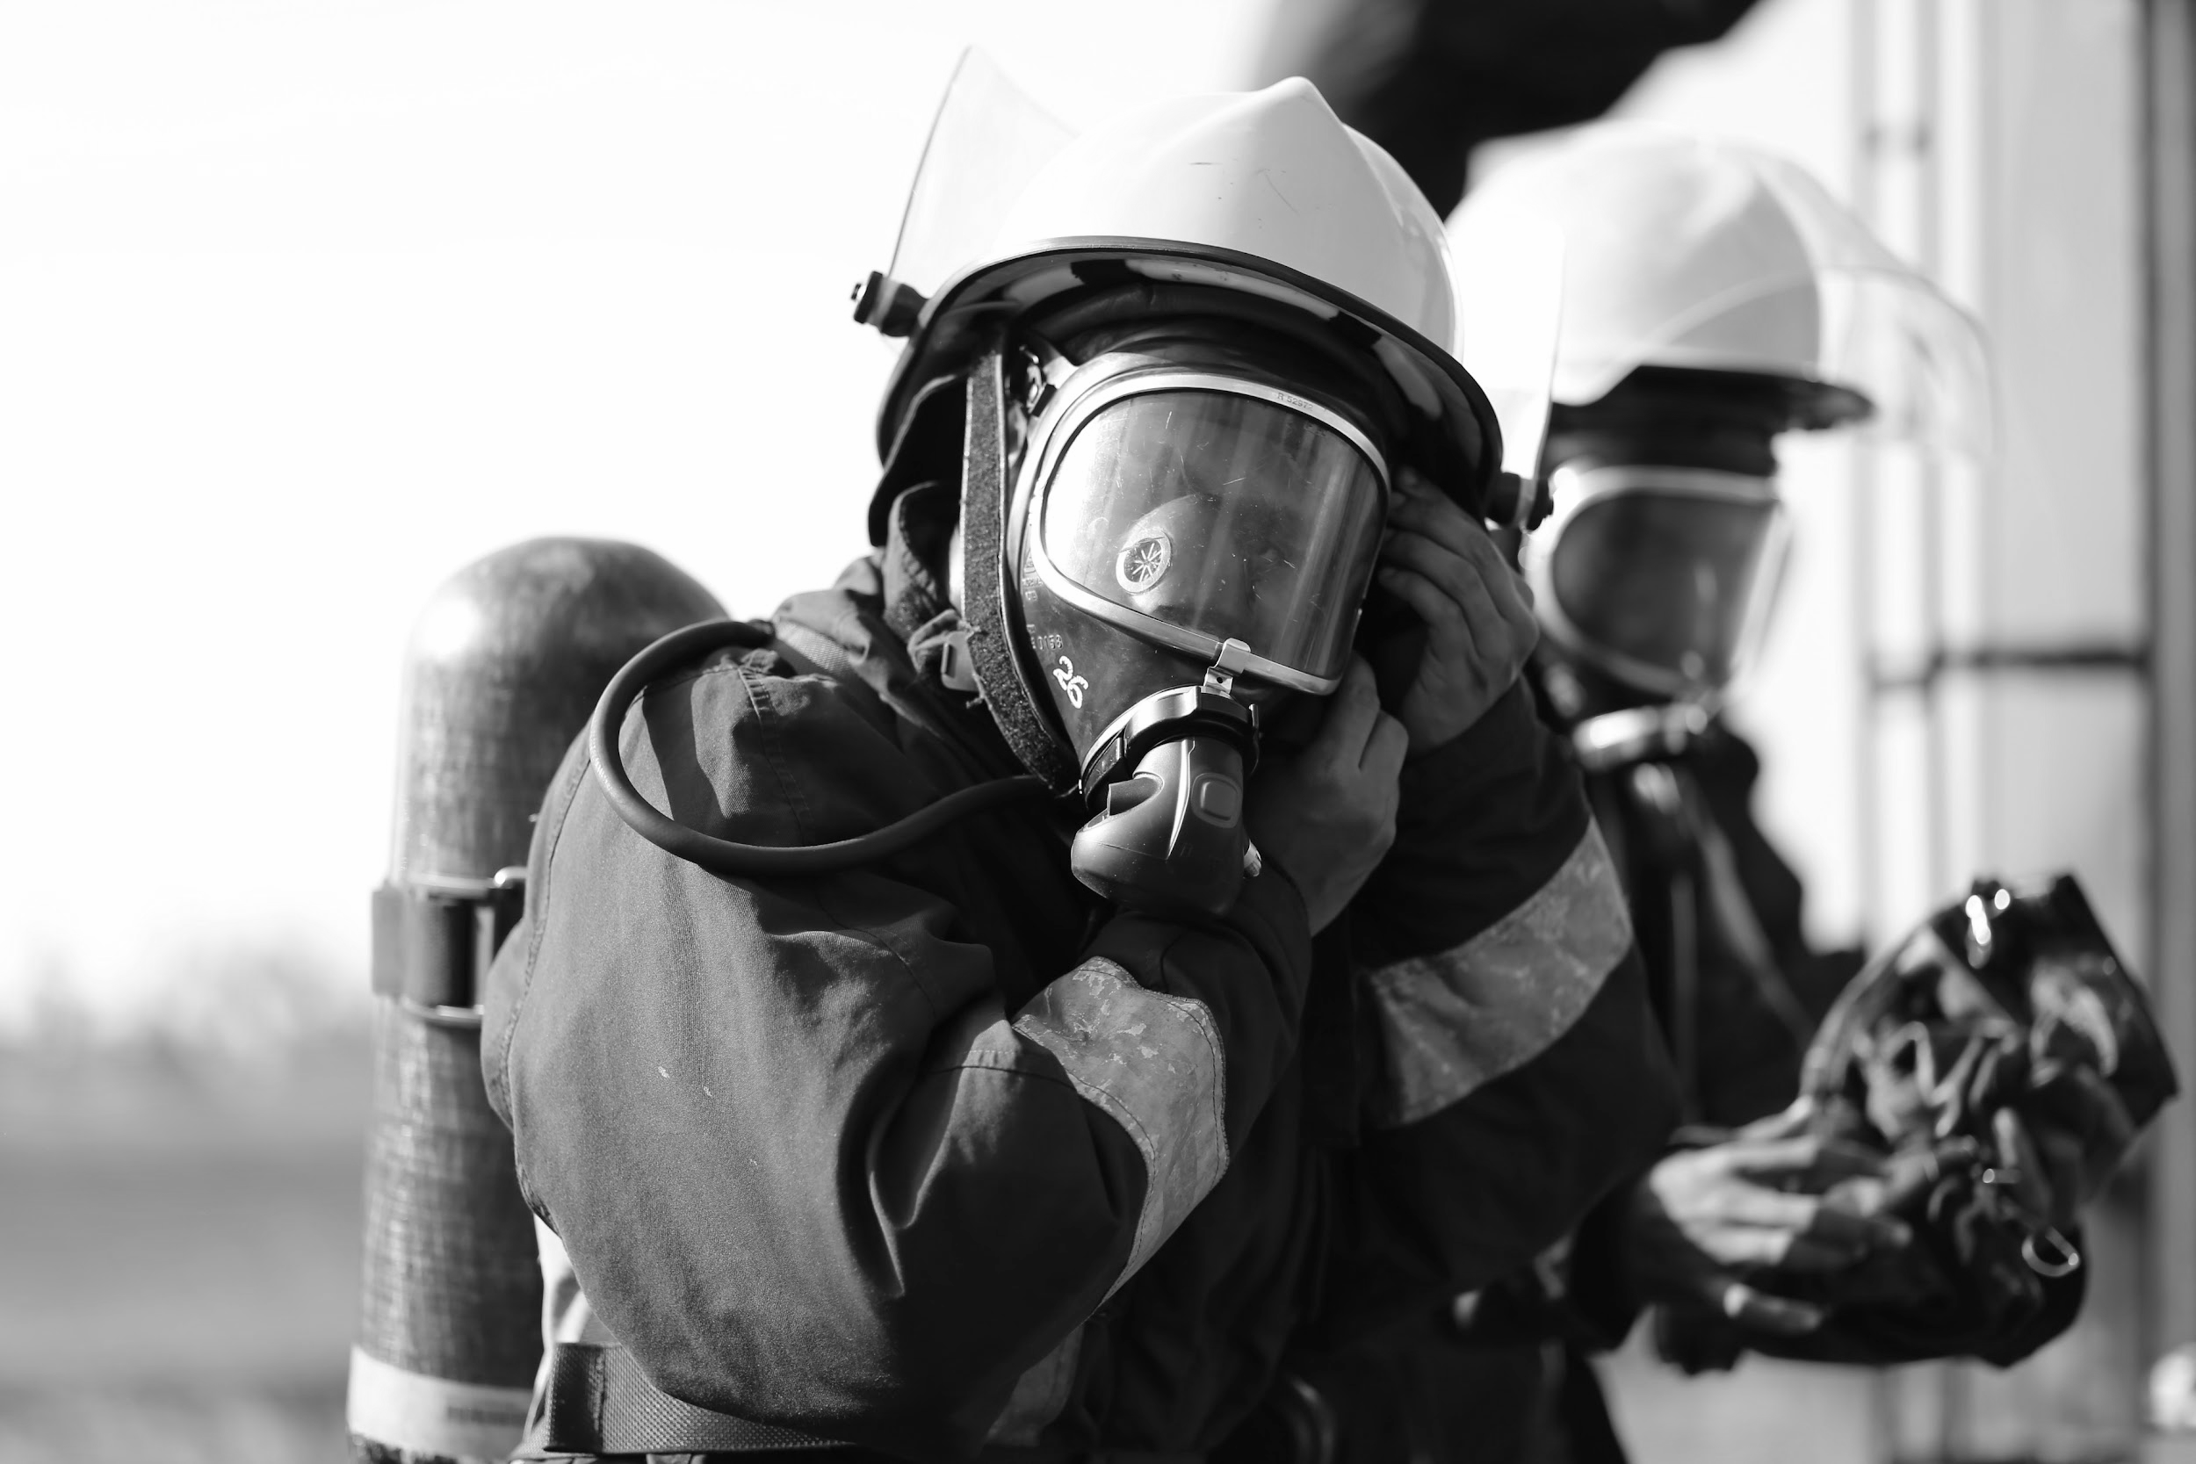  Firefighters’ masks protect them from dangerous emissions.
What’s your prediction?  My Answer: |  | What’s your prediction?  My Answer:
Correct Definition: |  | Correct Definition:

5. Industry [in-duh-stree] |  | 6. Lethal [lee-thuhl]
The construction industry in New York has taken off in the last ten years — new buildings are going up everywhere. |  | Use child-safe locks to keep children away from lethal chemicals.
  The restaurant industry suffers when bad weather keeps diners at home. |  | 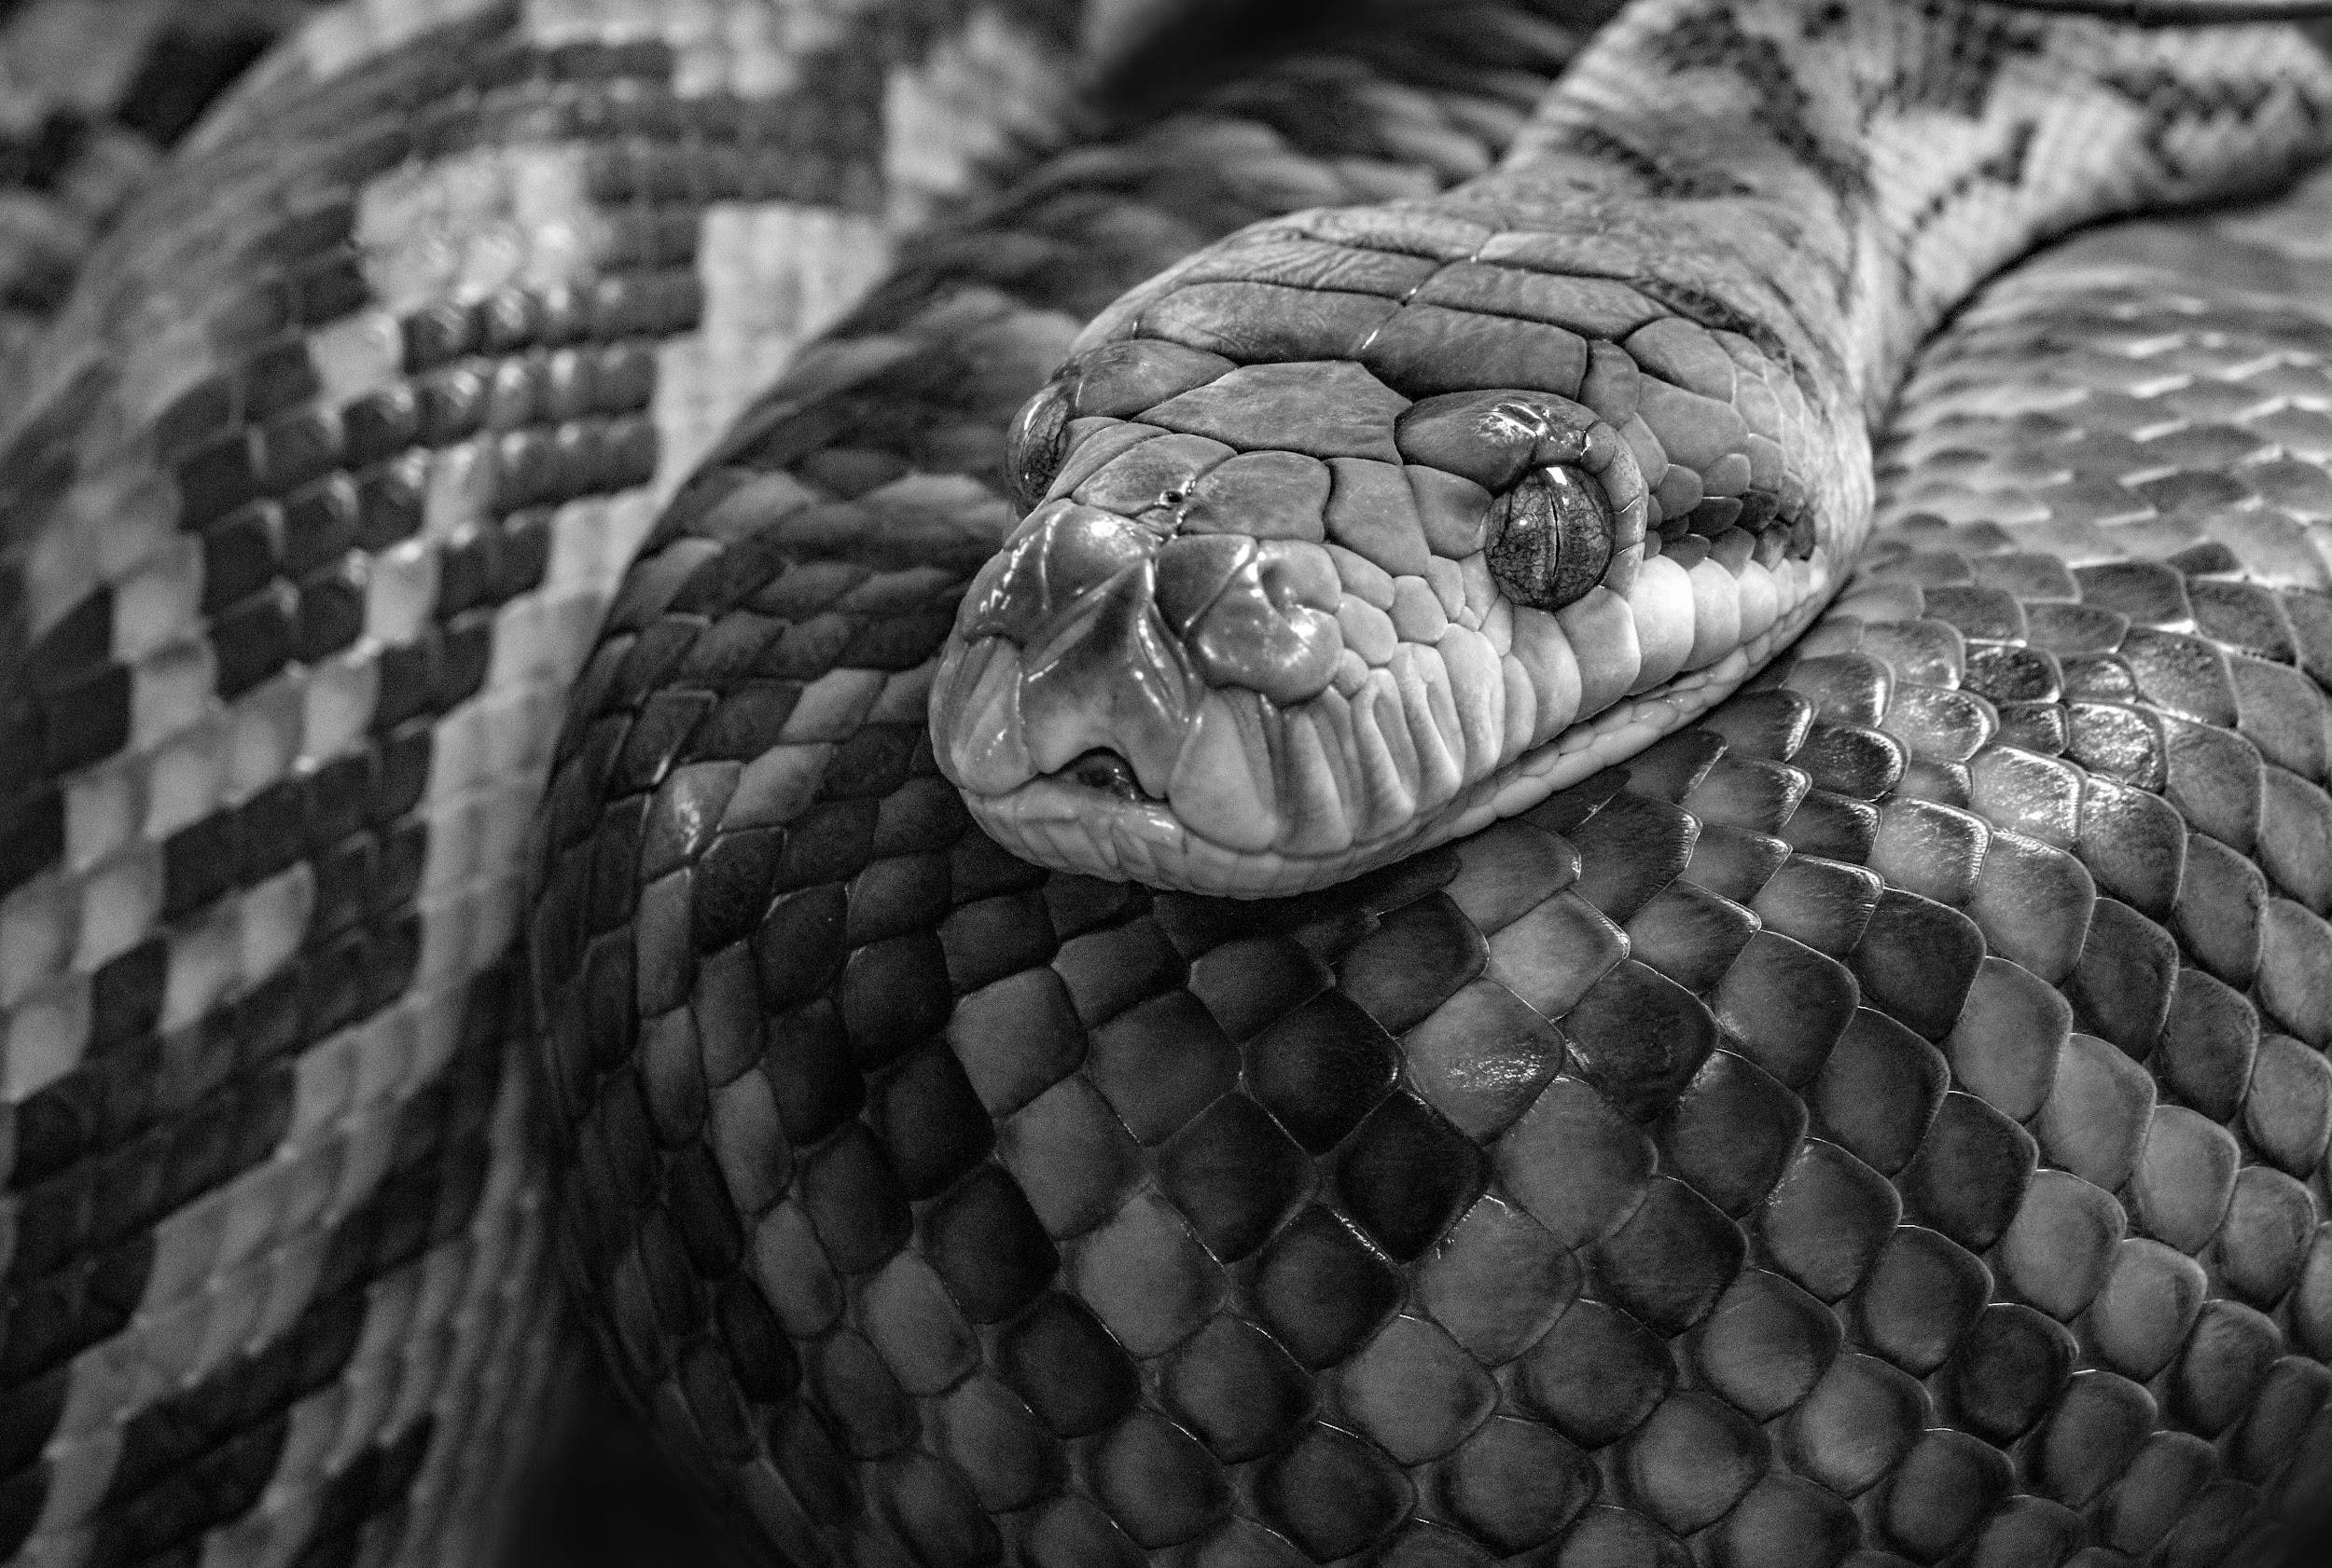  A rattlesnake’s bite can be lethal if not treated quickly.
What’s your prediction?  My Answer: |  | What’s your prediction?  My Answer:
Correct Definition: |  | Correct Definition:

7. Livelihood [lahyv-lee-hood] |  | 8. Toxic [tok-sik]
I won’t fight with my boss and risk losing my livelihood. |  | The doctors had to pump the toddler’s stomach after he  swallowed a toxic household cleaning product.
  Mara’s livelihood depends on customers coming into her bakery. |  | 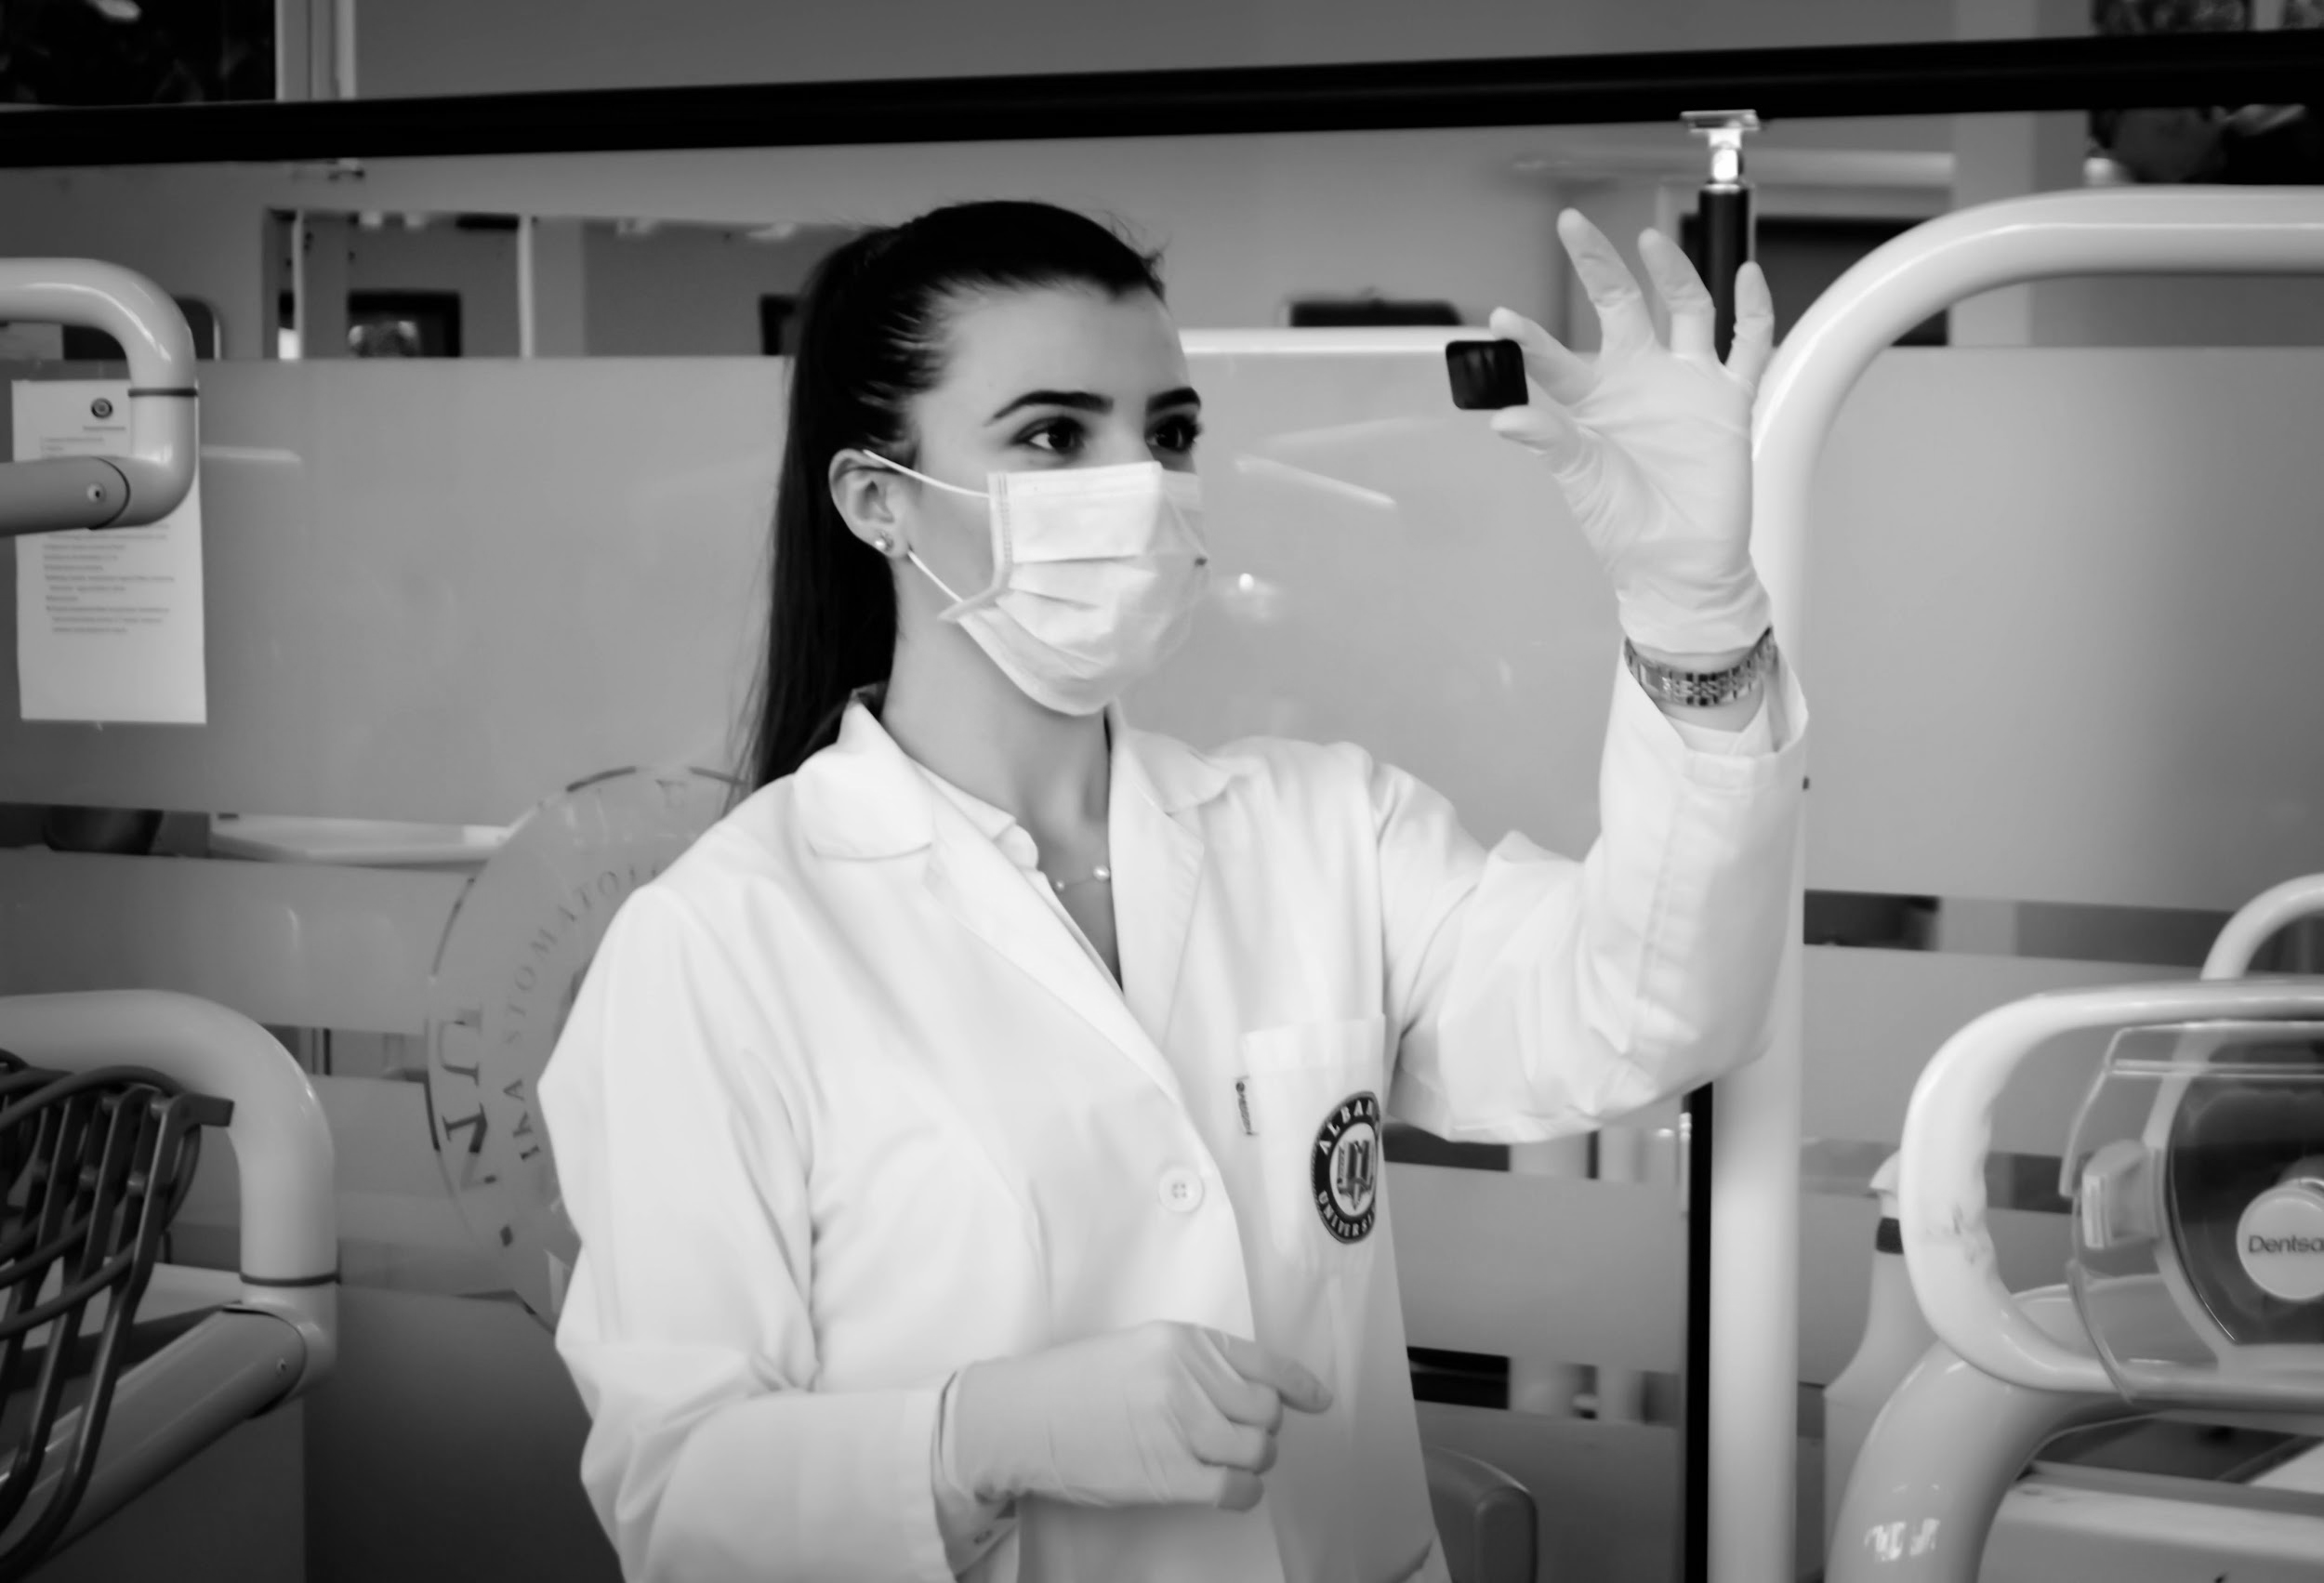  Dr. Garcia wears protective gear when working with toxic substances.
What’s your prediction?  My Answer: |  | What’s your prediction?  My Answer:
Correct Definition: |  | Correct Definition:

Activity 2: Fill-in-the-Blank Sentences  Directions: Fill in the blanks using the correct vocabulary word to complete each sentence. You may have to change the form of the word (ex: go, going, gone). | 

Accumulate Contaminate Dispose Emissions Industry Lethal Livelihood Toxic

My answer
- I don’t care if you sell those things or throw them away, but you need to ____ of them somehow.
- That terrible storm destroyed the farmer’s crops and his ____.
- We were shocked to learn that the leak from the factory was ____ our drinking water.
- The local authorities built a fence along the cliff after several tourists suffered ____ falls.
- Please don’t let the trash ____ all week — it makes the kitchen smell terrible!
- The factory claims its ____ are safe, but community groups say those gases are dangerous.
- Never eat a bright red mushroom; that color means that they’re ____!
- The taxi ____ is struggling these days because of services like Lyft and Uber.

Activity 3: Fill-in-the-Blank Scenarios
Directions: Fill in the blanks using the correct vocabulary word to complete each scenario. Then, explain why that vocabulary word fits best based on context clues provided in the scenario. You may have to change the form of the word (ex: go, going, gone).

For Example:

Every single day, Bryan wakes up at 5 o’clock in the morning to take a 10-mile jog. Then, he goes to the gym to lift weights. Afterwards, he does 20 laps in the pool. And this is before he goes to practice with the team every afternoon!
Bryan is ____________ about training because __________________________________________________________.
My Answer | My Reason
relentless | He is extremely dedicated and exercises all of the time. He runs 10 miles, lifts weights, swims, and attends practice every day.

Accumulate Contaminate Dispose Emissions Industry Lethal Livelihood Toxic

- In her first year of teaching, Ms. Lee got one thank you card from a student. She got a few more every year and now, after a 40-year career, she has hundreds of them!
Ms. Lee has ___________________ thank you cards because __________________________________________________
My Answer | My Reason

- If you look at a bottle of bathroom cleaner with bleach in it, you will see that the label says, “DO NOT use with products containing ammonia.” Although bleach and ammonia are both safe to breathe in small doses, the combination of their fumes is poisonous and can cause a person to pass out or even die. Never use bleach and ammonia together!
Combining bleach and ammonia is ___________________ because _____________________________________________
My Answer | My Reason

- After the party was over, Diego went through the house gathering up trash. He threw away two bags full of food scraps, plastic cups and plates, and paper napkins.
Diego ___________________ of the trash because ___________________________________________________________
My Answer | My Reason

- Dr. Abboud and Dr. Green were testing household cleaning products in their lab. The first product checked out as completely safe for home use — even the fumes it produced were safe to breathe. However, they smelled so awful that the two scientists doubted many people would be willing to buy the product!
The cleaning product has unpleasant ___________________ because ___________________________________________
My Answer | My Reason

- Tyrell is a very talented painter, but it’s hard to make a living as an artist. In order to pay his rent and put food on the table, Tyrell waits tables at a fancy restaurant downtown.
Waiting tables is Tyrell’s ___________________ because ______________________________________________________
My Answer | My Reason

- From 1910 to 1980, the United States ruled the automobile market. U.S. companies produced and sold more cars than companies in any other nation. In 1978, American automakers sold nearly 13 million cars! Then, the rise of Japanese companies in the 1980s knocked the U.S. out of first place in car sales, as customers bought the less expensive Japanese models.
Automobile manufacturing is a(n) ___________________ because ______________________________________________
My Answer | My Reason

- It is incredibly important to wear a seat belt every time you ride in a car. Passengers not wearing a seat belt are twice as likely to die in a car accident as their buckled-up peers.
Not wearing a seat belt can be ___________________ because _________________________________________________
My Answer | My Reason

- When LaShay was packing her groceries, she put a bottle of bleach in the same bag as a container of strawberries. She didn’t realize that the bleach was leaking. When she got home, LaShay noticed that her strawberries smelled like bleach!
The bleach has ___________________ the strawberries because _______________________________________________
My Answer | My Reason

Activity 4: Matching
Directions: Match the following vocabulary words to their synonyms from the box. Write your answer in the column next to the word.

Synonyms: Business Dump Collect Poisonous Dirty Living Deadly Leak

Words | My Answer
- Accumulate
- Contaminate
- Dispose
- Emissions
- Industry
- Lethal
- Livelihood
- Toxic

Activity 5: Application of Vocabulary
Directions: Answer each question in 1-2 complete sentences. Make sure that you use the underlined vocabulary word in your answer.

- Some people accumulate objects with emotional meaning to them, while other people throw away things quickly. Which type of person are you? Why?

- What do you think should be the punishment for a company that contaminates the air or water? Why?

- What should companies think about when deciding how to dispose of dangerous chemicals?

- We have the technology to reduce car emissions, but using it would make cars more expensive to build and sell. Do you think car companies should be forced to use this emissions-lowering technology? Why or why not?

- What industry would you like to work in when you grow up? Why?

- How can lethal car accidents be prevented?

- Sometimes laws that protect the environment can threaten people’s livelihoods. Which do you think is more important to protect? Why?

- Although the smoke from cigarettes and vaporizers (or “vape pens”) is toxic, they are still legal. Do you think they should be? Why or why not?

